Back Pain

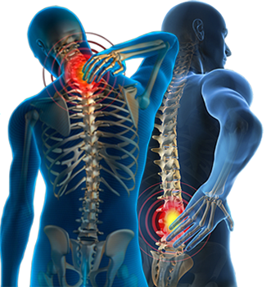

Back pain is a common reason for absence from work and for seeking medical treatment. It can be uncomfortable and debilitating. It can result from injury, activity, inactivity, repetitive strain issues, poor posture and some medical conditions. Most lower back issues start between the ages of 30 and 50, and the pain tends to get more common over time, but back pain can happen to people of any age for varying reasons.

What are some back pain symptoms?
Your pain may be dull or sharp. It may come and go. Depending upon its source, pain may get worse with standing, sitting, bending, driving or walking. Pain can even extend into your buttock or leg.
Acute, or short-term back pain lasts a few days to a few weeks. Most low back pain is acute. It tends to resolve on its own within a few days with self-care and there is no residual loss of function.
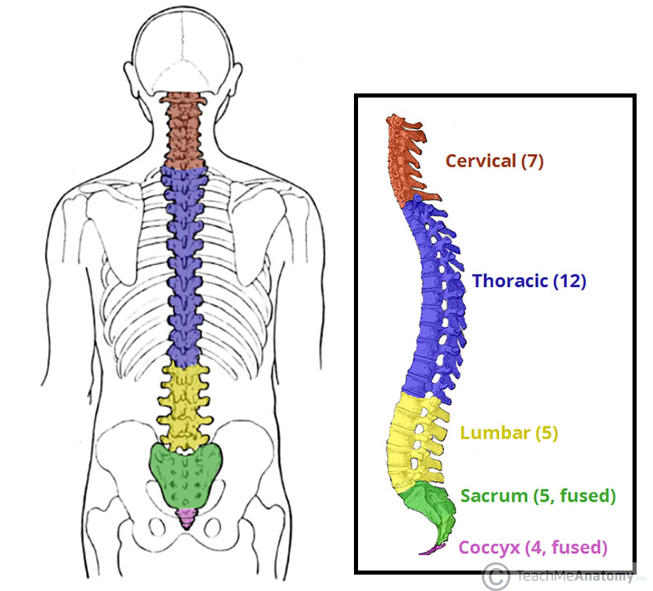
In some cases a few weeks or months are required for the symptoms to disappear and the help of a therapist is needed.

Back pain is divided into neck pain (cervical), middle back pain (thoracic), lower back pain (lumbar) or coccydynia (tailbone or sacral pain) based on the segment affected.

How can stress contribute or lead to back pain?
Cortisol and adrenaline are released when we are stressed, and there is typically an involuntary tightening of your muscles. This often occurs in the neck, shoulders, and down the spine. Prolonged tension in these areas can lead to pain and stiffness in the back.

How to relieve back pain?
- Staying active : stay as active as possible and try to continue your daily activities.
- Exercising : Try exercises and stretches for back pain. Other activities such as walking, yoga , swimming, and pilates may be helpful.
- Medicine : Take anti-inflammatory painkillers but contact your GP or pharmacist first.
- Manual Therapy : Get in touch with your local Neuromuscular Therapist to book an appointment. These treatments can include mobilisations of the spinal region, massage and specific exercises.
- Surgery : This is usually the last option and is only considered when all other avenues have been considered and explored

When to see your GP?
You’ll typically see improvements within two to six weeks of doing daily exercises. You should see a doctor if :
- your pain doesn’t improve within a few weeks
- you have intense pain or it is getting worse over time
- the pain spreads to your legs
- you’re worried about the pain or struggling to cope in your daily life
Also see a doctor if you experience any numbness, swelling, or severe pain. Your doctor can help to determine if any pain or tightness is being caused by an underlying condition.

Preventing back pain :
- Doing regular exercises and stretches. Your GP or Neuromuscular Therapist may be able to advise you on exercises to try
- Avoid sitting for long periods
- Taking care when lifting
- Making sure the mattress on your bed supports you properly
- Losing weight – being overweight can increase your risk of developing back pain
- Checking and being aware of your posture when sitting, driving and standing

Back Pain Statistics (UK) :

- Back pain alone accounts for 40% of sickness absence in the NHS
- Overall it costs the UK economy 10 billion per year
- Back pain is the largest single cause of disability in the UK (11% of total disability)
- Referrals for spinal surgery are increasing year on year
- 4/5 (80%) adults will experience back pain at some point in their lives

Prevention is better than cure…..book yourself in for a full body massage every month. This can help you relax, destress, and so your therapist can assess you and release any tension that is stored in your muscles.
You deserve it!!!

https://kptherapy.ie/#booking
https://www.instagram.com/kptherapy.ie/

